**PRACTICAL - 5**

**AIM:** Demonstrate the EIGRP and BGP protocol configuration using cisco packet tracer.

**THEORY:**

**BGP Protocol:**

* **Border Gateway Protocol (BGP) is an Internet Engineering Task Force (IETF) standard, and the most scalable of all routing protocols.**
* **BGP is the routing protocol of the global Internet, as well as for Service Provider private networks.**
* **BGP has expanded upon its original purpose of carrying Internet reachability information, and can now carry routes for Multicast, IPv6, VPNs, and a variety of other data.**
* **Cisco supports all IETF BGP standards, as well as most or all Internet Drafts for BGP. In addition, Cisco is an active participant in the BGP working groups at the IETF and a frequent contributor of new BGP extensions.**

**EIGRP Protocol:**

* **Enhanced Interior Gateway Routing Protocol (EIGRP) is an interior gateway protocol suited for many different topologies and media.**
* **In a well designed network, EIGRP scales well and provides extremely quick convergence times with minimal network traffic.**
* **Very low usage of network resources during normal operation; only hello packets are transmitted on a stable network**
* **When a change occurs, only routing table changes are propagated, not the entire routing table; this reduces the load the routing protocol itself places on the network**
* **Rapid convergence times for changes in the network topology (in some situations convergence can be almost instantaneous)**

**EIGRP PROTOCOL CONFIGURATION:**

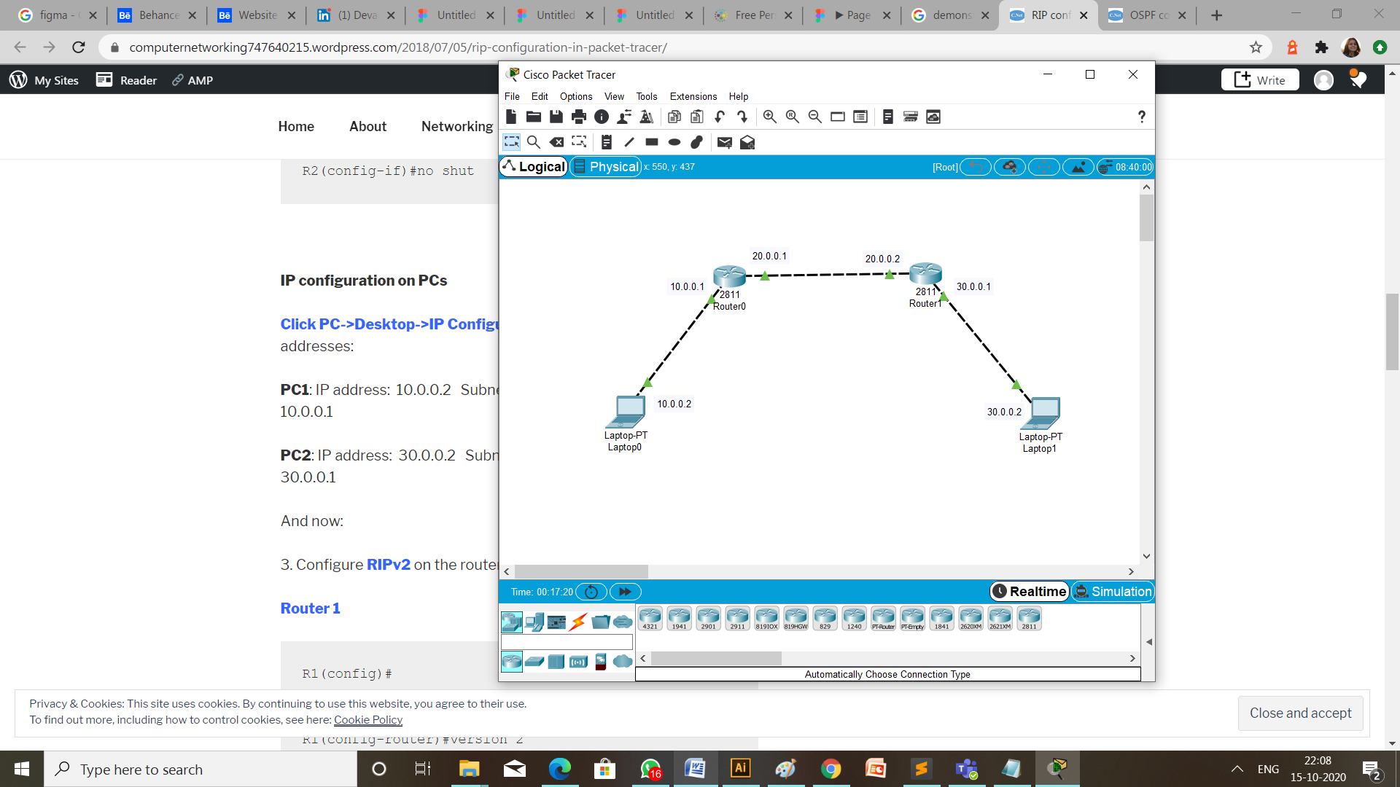**TOPOLOGY:**

**STEPS OF CONFIGURATION**

1. **First of all to create a topology, click on the device and drop on workplace and connect all the devices with the necessary cables.**
2. **Then configure all the router using CLI and give the ip address as mention in the topology diagram.**
3. Router 1: fa0/0 1.0.0.1

fa0/1 2.0.0.1

1. Router 2: fa0/0 2.0.0.2

fa0/1 3.0.0.1

1. **Provide ip address and default gateway to the laptops.**
2. Laptop 1: ip address is 1.0.0.2

default gateway is 1.0.0.1

1. Laptop 2: ip address is 3.0.0.2

default gateway is 3.0.0.1

1. **Configuration of EIGRP on router 0 and router 1 are respectively,**

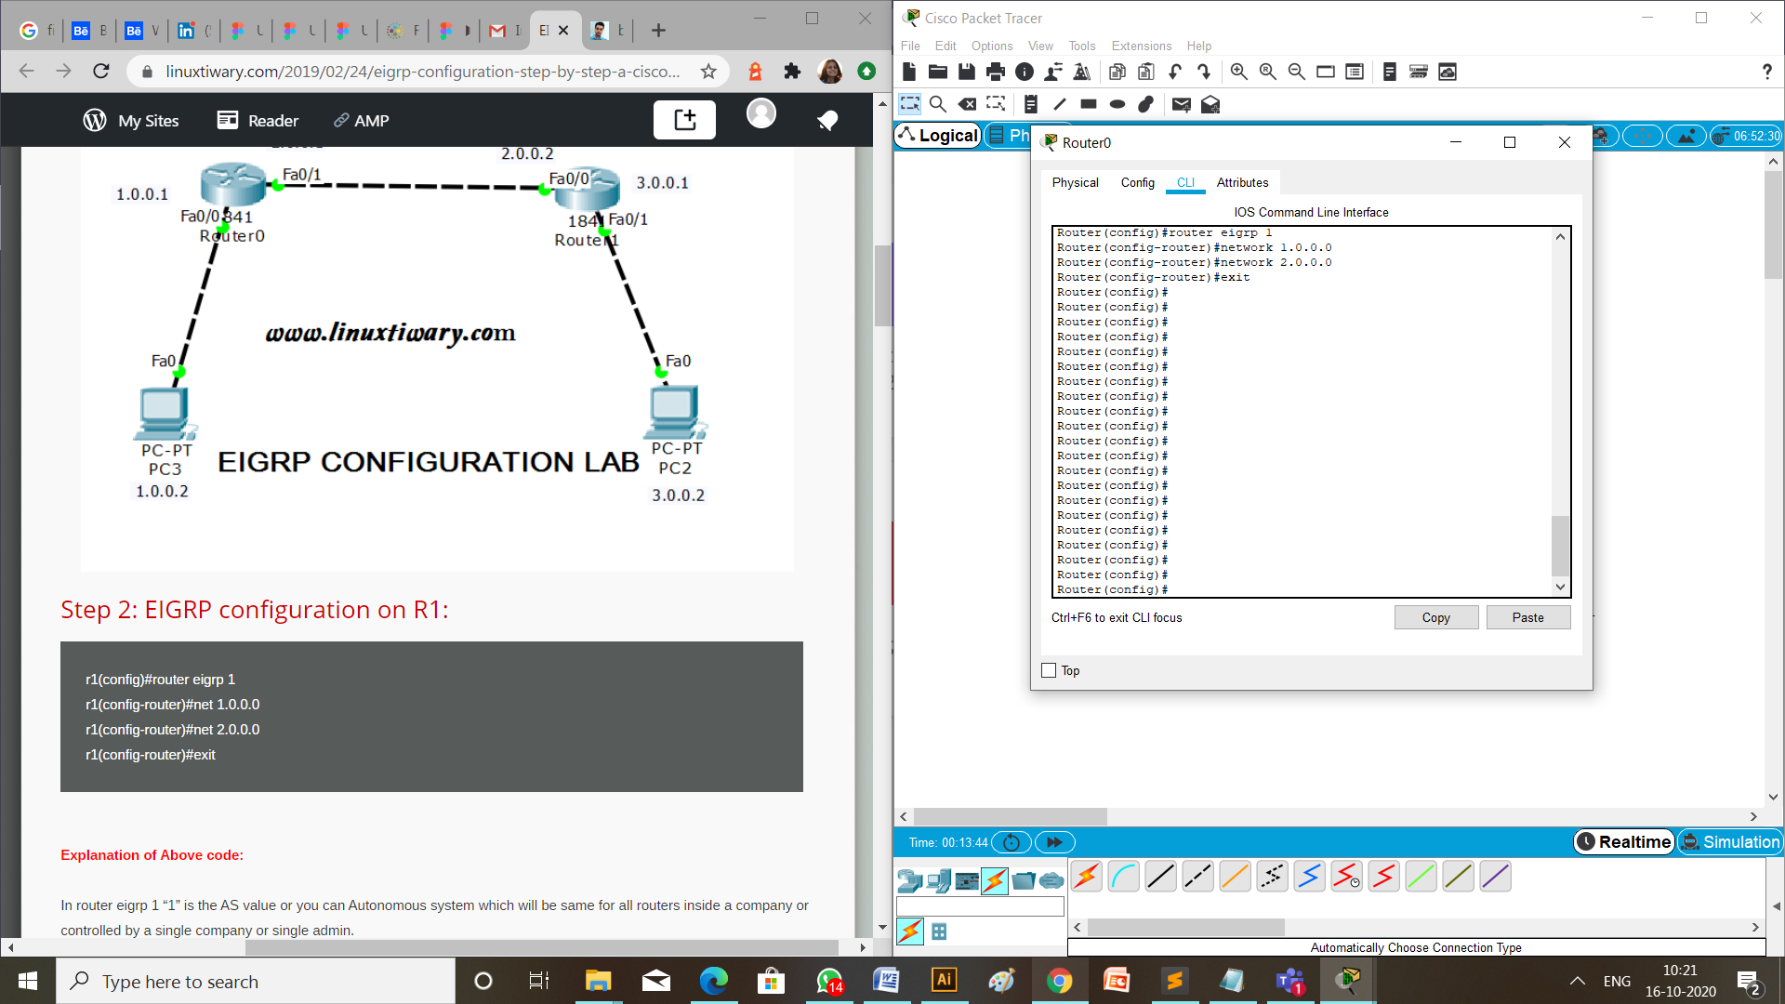

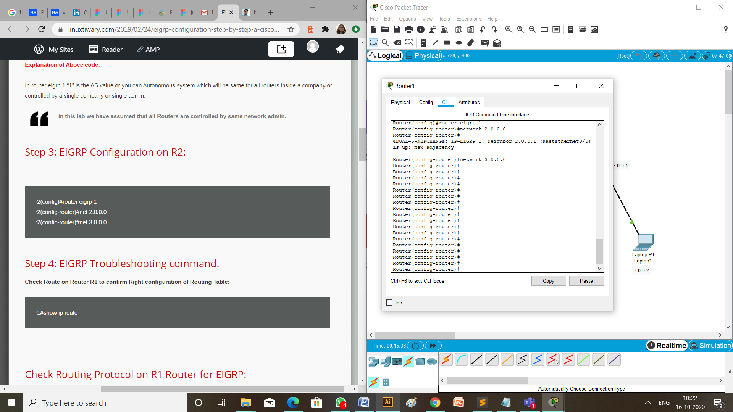

1. **Verify EIGRP configuration.**

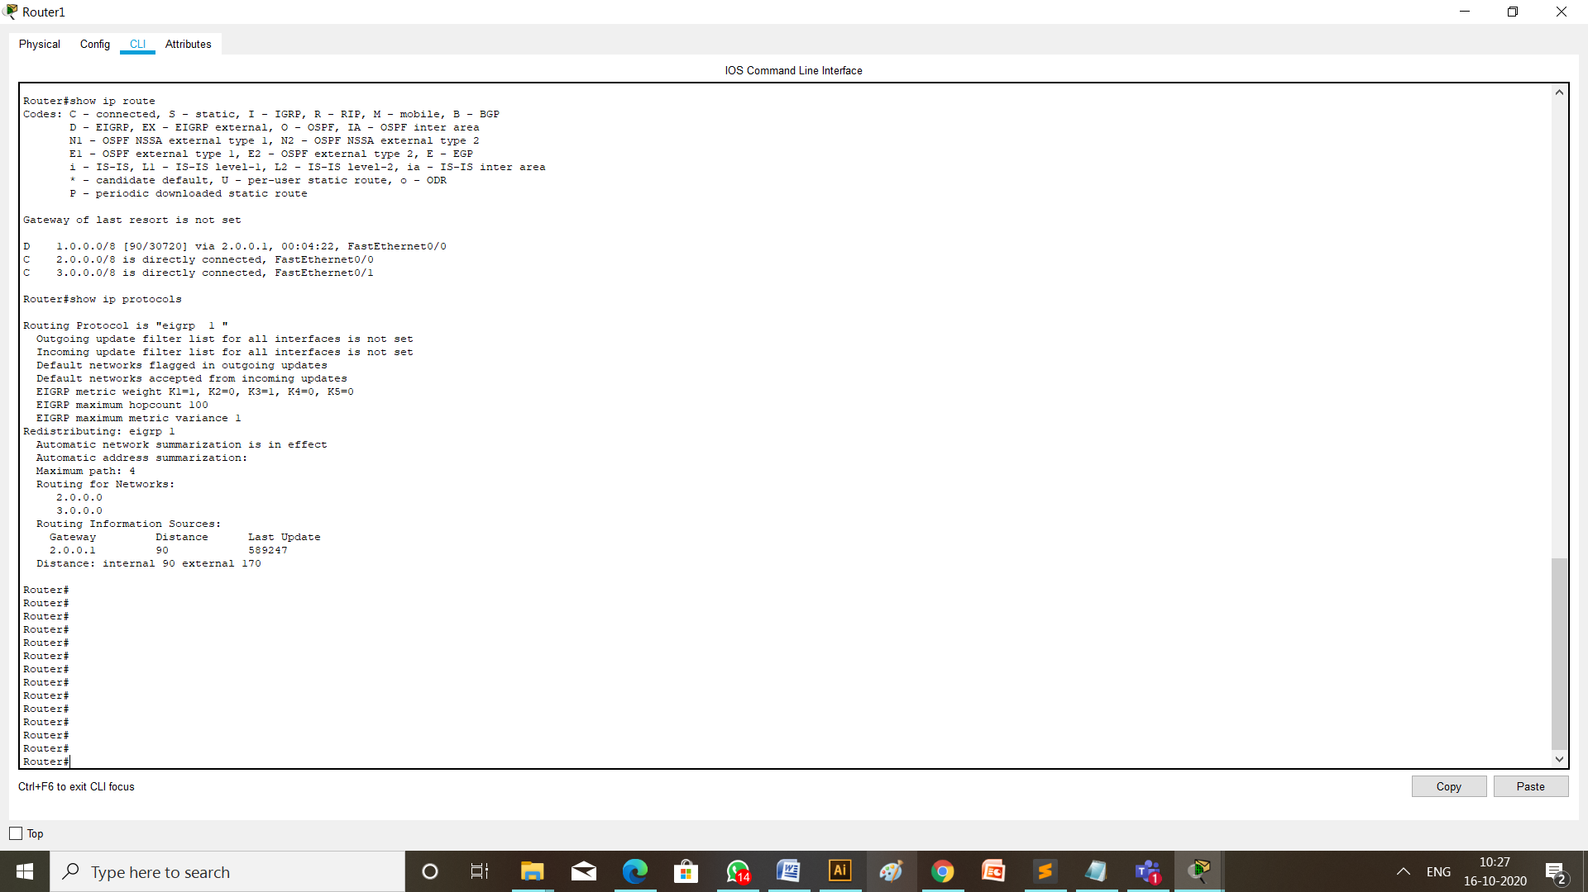

**CHECK NETWORK TOPOLOG**

We can check if the connection is working properly by two ways:

1. **MESSAGE PASSING**

To check the connections are working properly or not drop one package on a Laptop 0 and receive it from the Laptop 1.

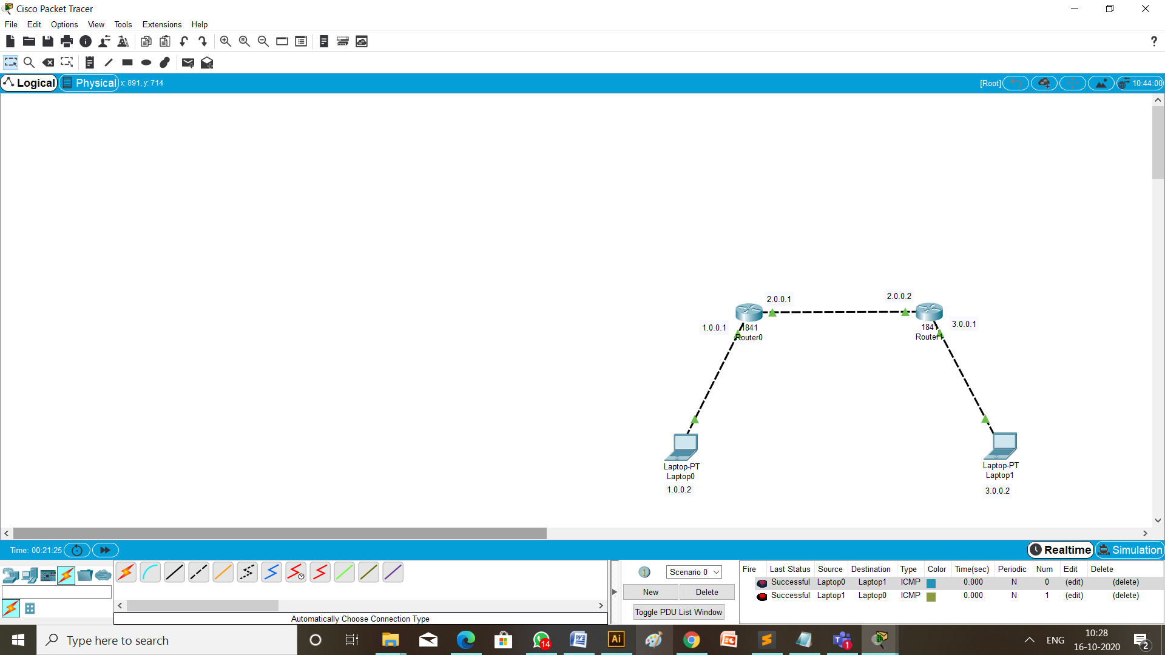

1. CHECKING NETWORK TOPOLOGY USING **PING** COMMAND

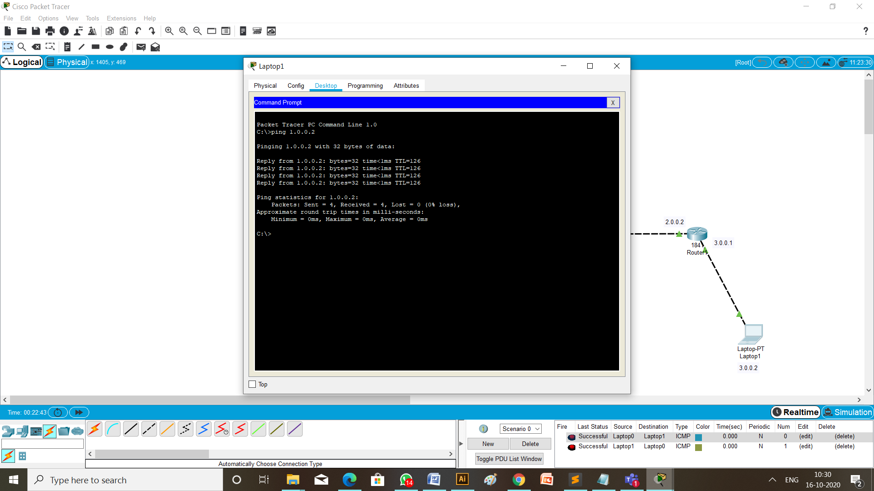

**BGP PROTOCOL CONFIGURATION:**

**TOPOLOGY:**

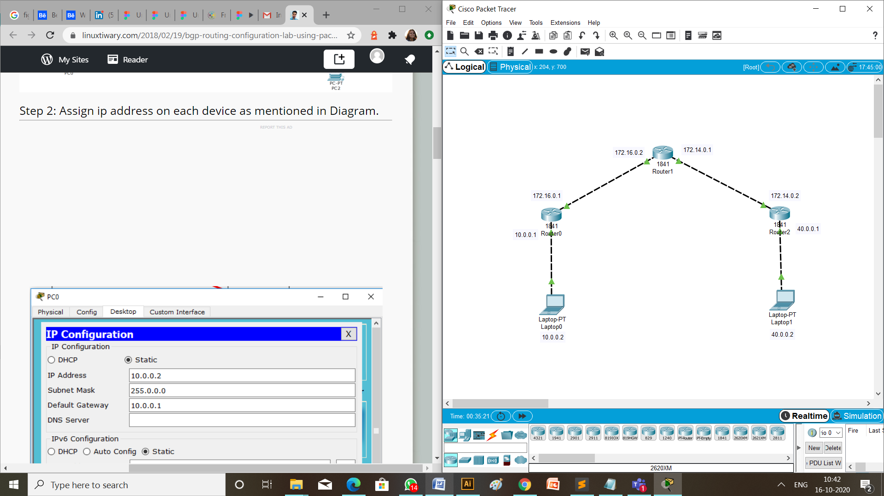

**STEPS OF CONFIGURATION**

1. First of all to create a topology, click on the device and drop on workplace and connect all the devices with the necessary cables.
2. Then configure all the router using CLI and give the ip address as mention in the topology diagram.
3. Router 1: fa0/0 10.0.0.1

fa0/1 172.16.0.1

1. Router 2: fa0/0 172.16.0.2

fa0/1 172.14.0.1

1. Router 2: fa0/0 172.14.0.2

fa0/1 40.0.0.1

1. Provide ip address and default gateway to the laptops.
2. Laptop 1: ip address is 10.0.0.2

default gateway is 10.0.0.1

1. Laptop 2: ip address is 40.0.0.2

default gateway is 40.0.0.1

1. Configuration of BGP on router 0, router 1 and router 2 are respectively,

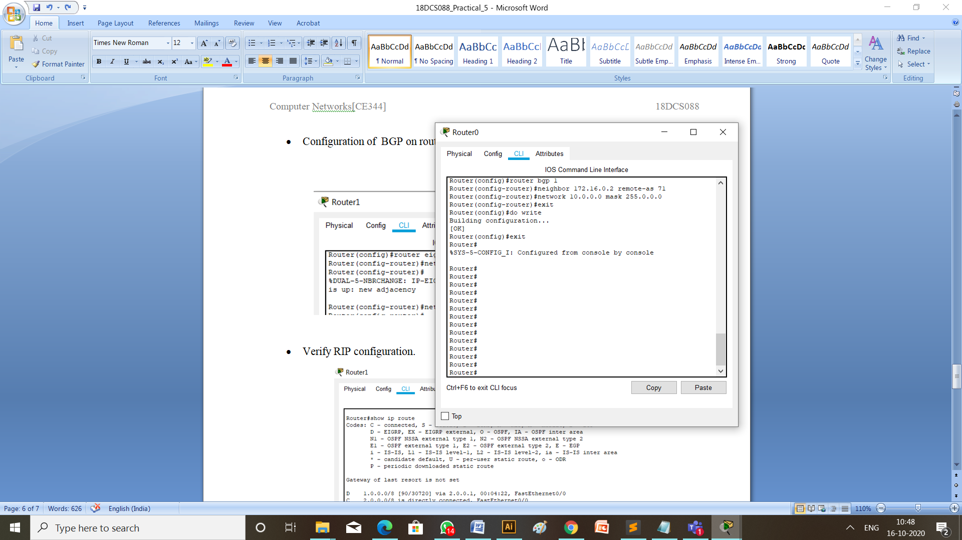

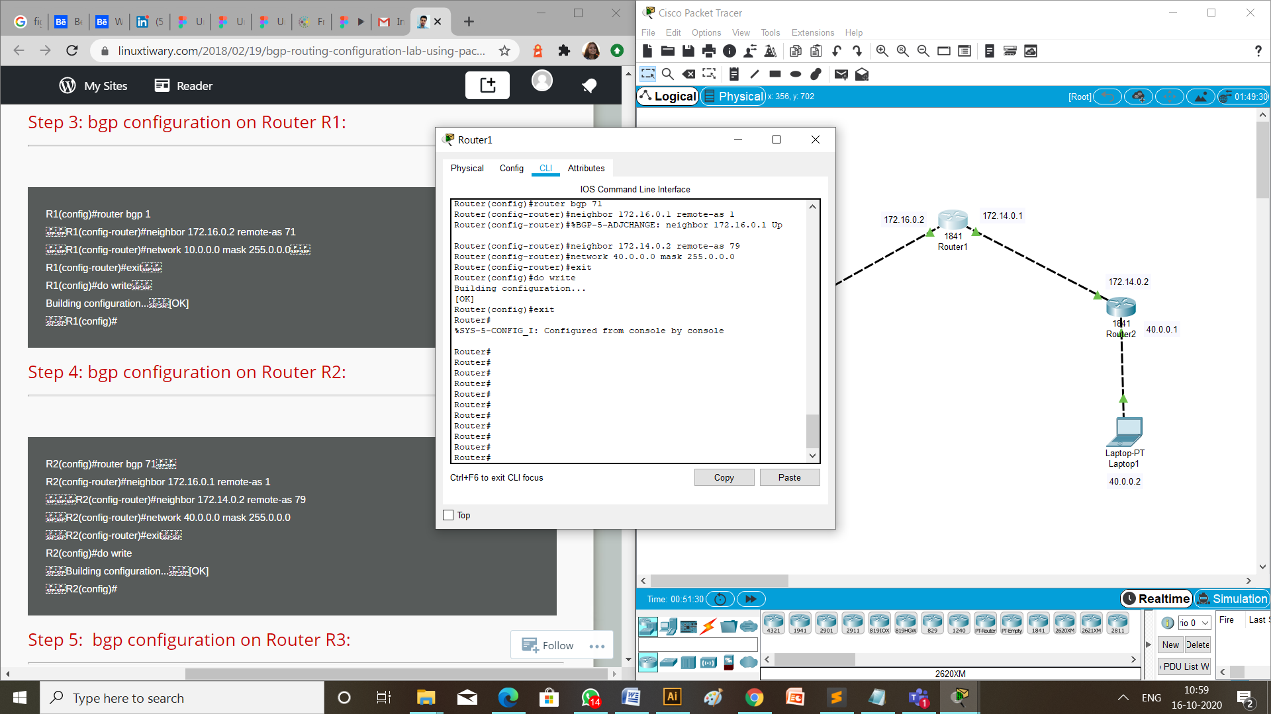

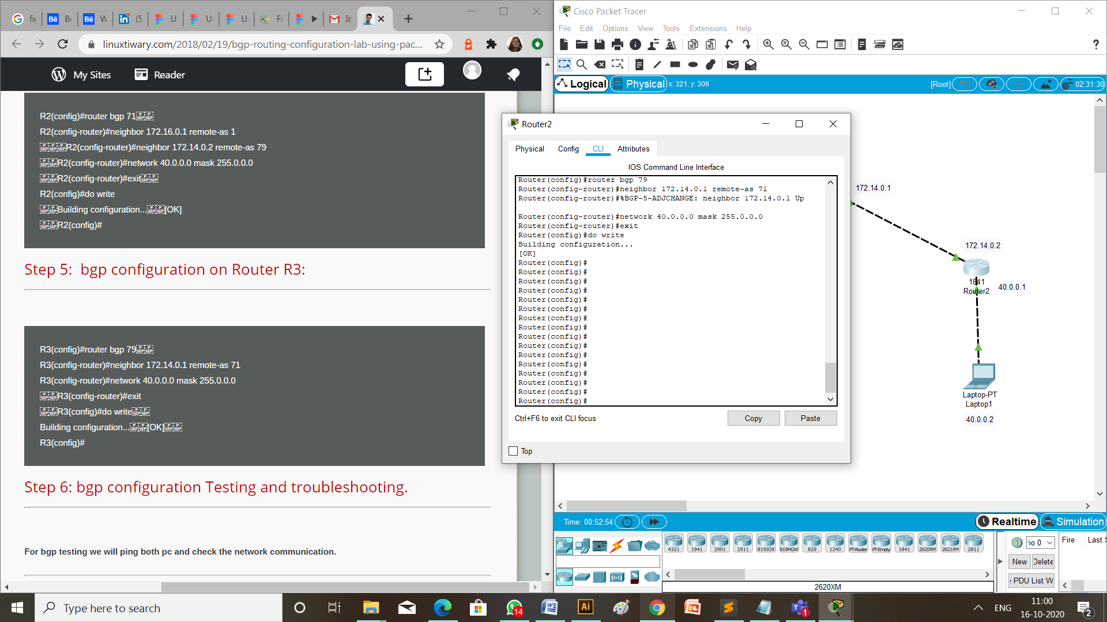

1. **Verify EIGRP configuration.**

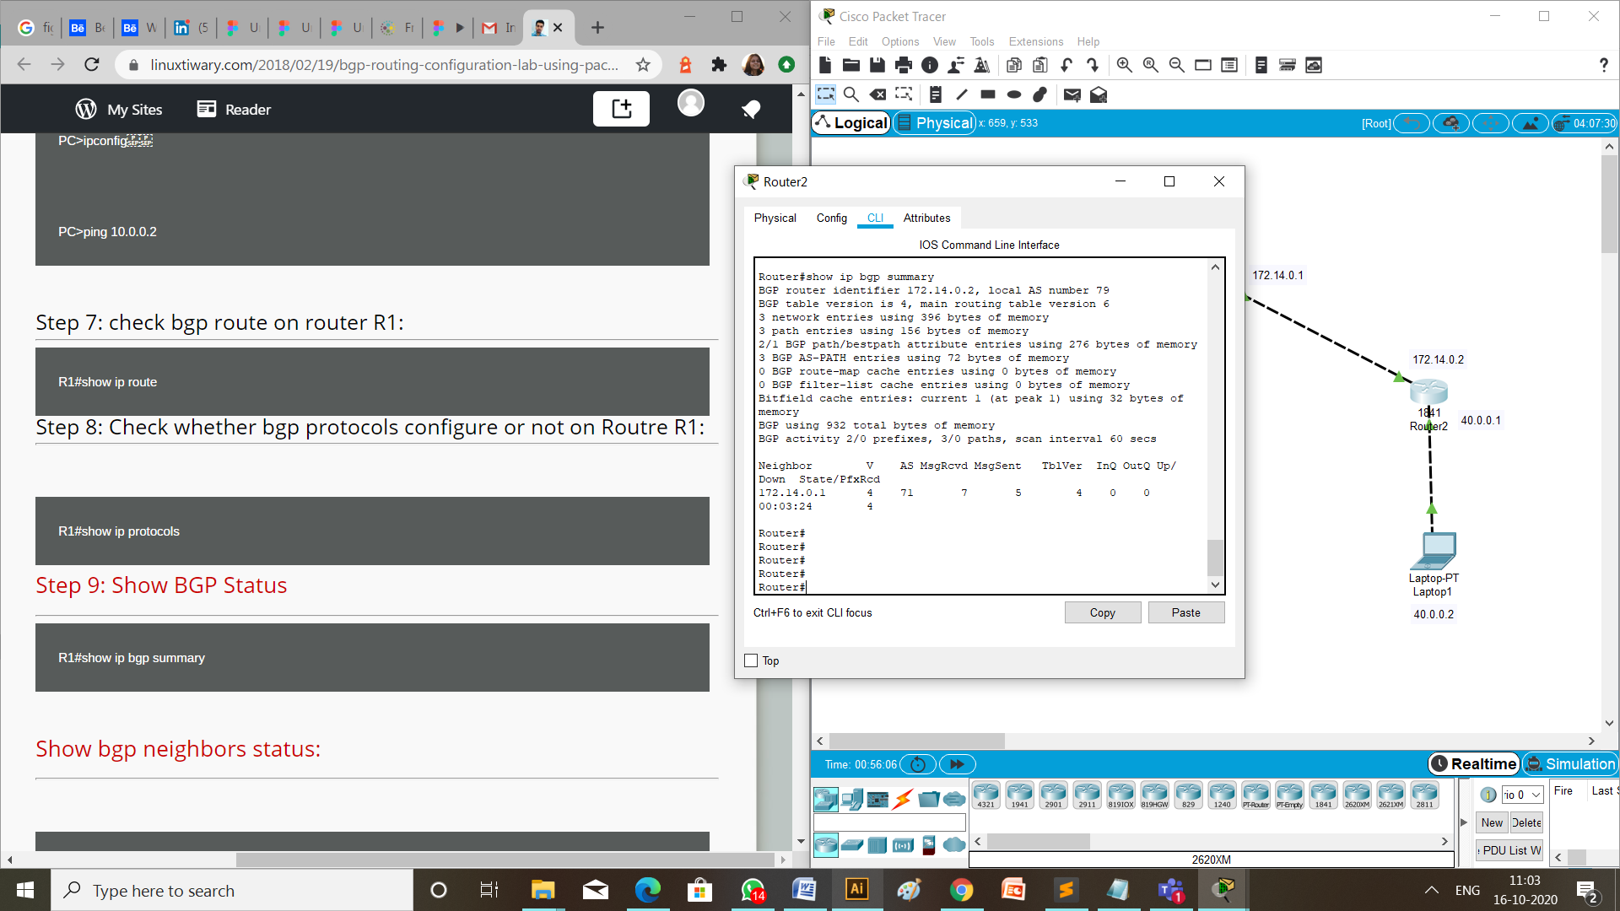

**CHECK NETWORK TOPOLOG**

1. **MESSAGE PASSING**

To check the connections are working properly or not drop one package on a Laptop 0 and receive it from the Laptop 1.

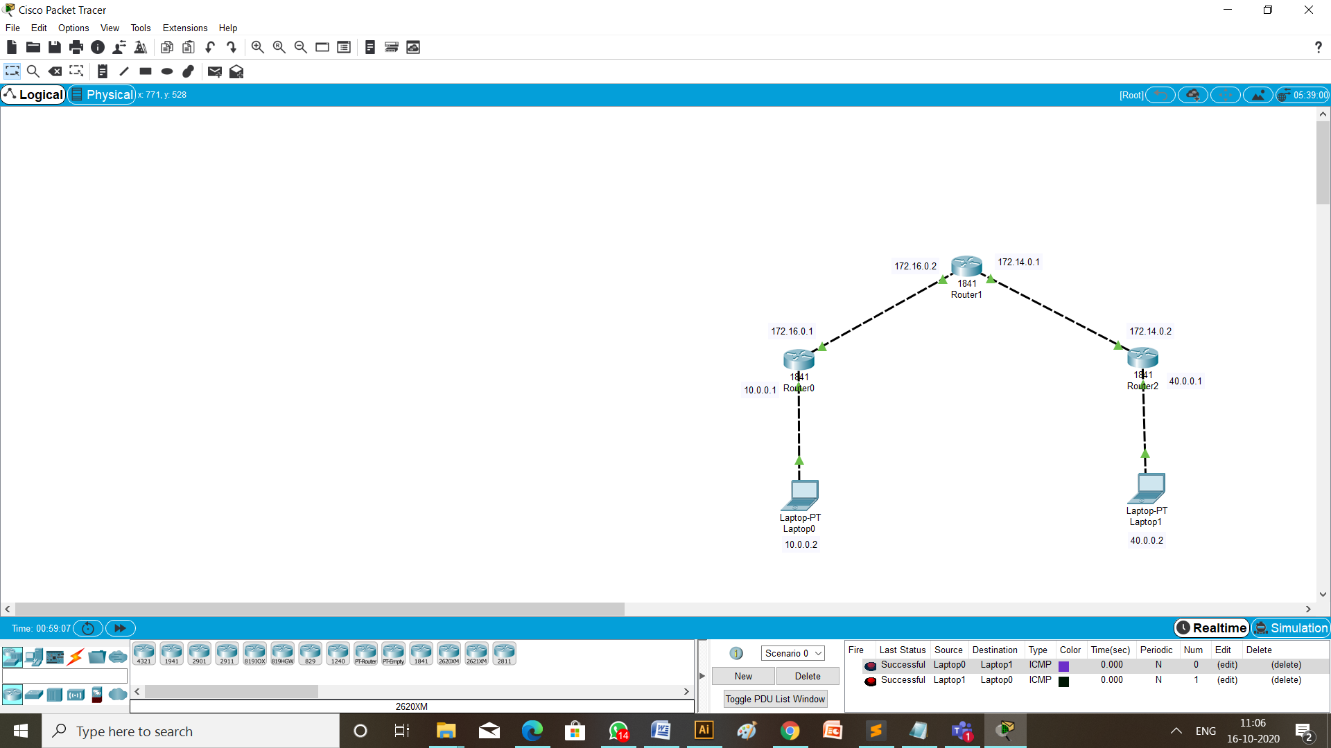

1. CHECKING NETWORK TOPOLOGY USING **PING** COMMAND

Write a command ping 40.0.0.2 (ip address of the destination Laptop) from the command prompt of Laptop having ip address 10.0.0.2 (the source Laptop).

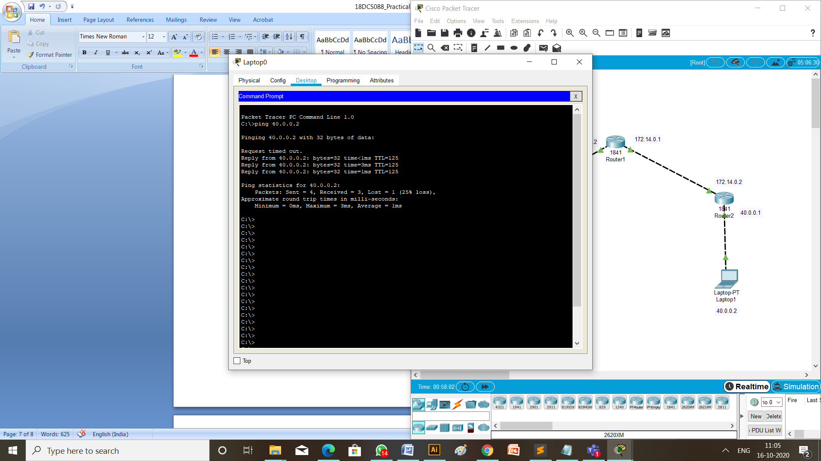

**CONCLUSION:**

Through this practical I learned about how to configure BGP and EIGRP protocols in different networks.